Julia Gonzalez

CSD 340

Assignment 5.2

Bio 250 words or more:

Eloisa is a mother and a caregiver who has dedicated her life to providing support and care to those in need. Growing up in a difficult situation, she learned the importance of hard work and compassion from an early age. She was unable to complete school as a child, however she continued education as an adult to obtain a high school diploma.

When Eloisa became a mother, she put her career and education on hold to focus on raising her children. However, her passion for helping others never faded. Once her children were grown, she returned to the workforce as a caregiver, providing assistance to disabled individuals in their homes.

Balancing work and family life has not always been easy, but Eloisa has found great fulfillment in her role as a caregiver. She takes pride in helping her clients maintain their independence and dignity, and is always there to listen and offer comfort.

Eloisa's dedication to her work has earned her recognition and respect from her colleagues and clients alike. She has received numerous awards for her exceptional care and compassion.

In her free me, Eloisa enjoys spending me with her family, going to the beach, and collecting her favorite ac on figures from local retailers. She also loves gardening and takes great joy in tending to her flower beds and vegetable garden.

Eloisa is an inspiration to all who know her. Her selflessness and dedication have touched the lives of many, and her unwavering commitment to helping others is a testament to the power of kindness and compassion.

Interview:

Q: What kinds of jobs have you worked?

A: Recently, I’ve mostly worked with people who have disabilities. My most recent client was a young man who had Dementia as well as other disabilities. He was someone who required 24 hour care because his case was a bit difficult. Covid was the main reason I decided to leave my previous job.

Q: I see. And how long have you been working in this field?

A: With this person in par cular it was about 5-6 years. In this field in general its been about 15 years. Now that I think it, I’ve worked this job pre y long.

Q: what did you like about the job you had?

A: Honestly, I learned a lot about people with special needs and I also learned how difficult it is to care for them. Not everyone has the same disability, some peoples disabili es are more advanced than others. Some mes you are even dealing with people that have mental health issues and that is when it gets dangerous. I did like that I learned so much and I had a good me with the people I cared for in the past.

Q: Do you have any hobbies?

A: I have a few. I collect ac on figures. I have some pre y amazing ones, like spider-man, Super Man, and Batman. They’re all 1:6 scale and look incredibly realis c. I also like to collect hot wheels I would show you all of them but its too many to get out of my storage space so here are a few of my original collec on. Even though I like collec ng, my favorite thing to do is go to the beach to relax and watch the sun set.

Q: Future goals?

A: I do have for the near future anyway. I want to finish my GED exam so I can start working as a phlebotomist. I want to work again soon so I can finish paying off my house but also being able to go on a vaca on would be nice.

Q: What are some of your greatest accomplishments?

A: This is an easy one. It’s my kids. You are all grown up, you, your sister and brother. You’re all my greatest accomplishment and I couldn’t be more proud to be your mom.

Q: What was your childhood like?

A: It was a li le bit difficult. There were eight of us (kids) and my parents both worked and I had to cook and clean in the morning, a er school and at night plus take care of my youngest brother and sister. I didn’t have a chance to be a kid at that me and I was only 11 years old.

Q: What was your childhood like before that?

A: I used to live in Mexico un l I was 11 years old. When we lived there I had a blast. There were only six of us then and my mom was home to care for us. I remember we (siblings+friends) used to go swimming in the river that was behind our house. Now that river is part of a park so they don’t allow swimming

Q: Did you like your move from Mexico to the US?

A: As a child not really. Mostly because we le behind friends and family behind in Mexico. We came to a place where we didn’t understand the language. We also came from a normal sized house to an apartment that was too small for all of us.

Q: What was your favorite thing about moving here?

A: Im not sure I can think of one but if we hadn’t come here I wouldn’t have met your dad or had any of you guys.

Color Wheel:

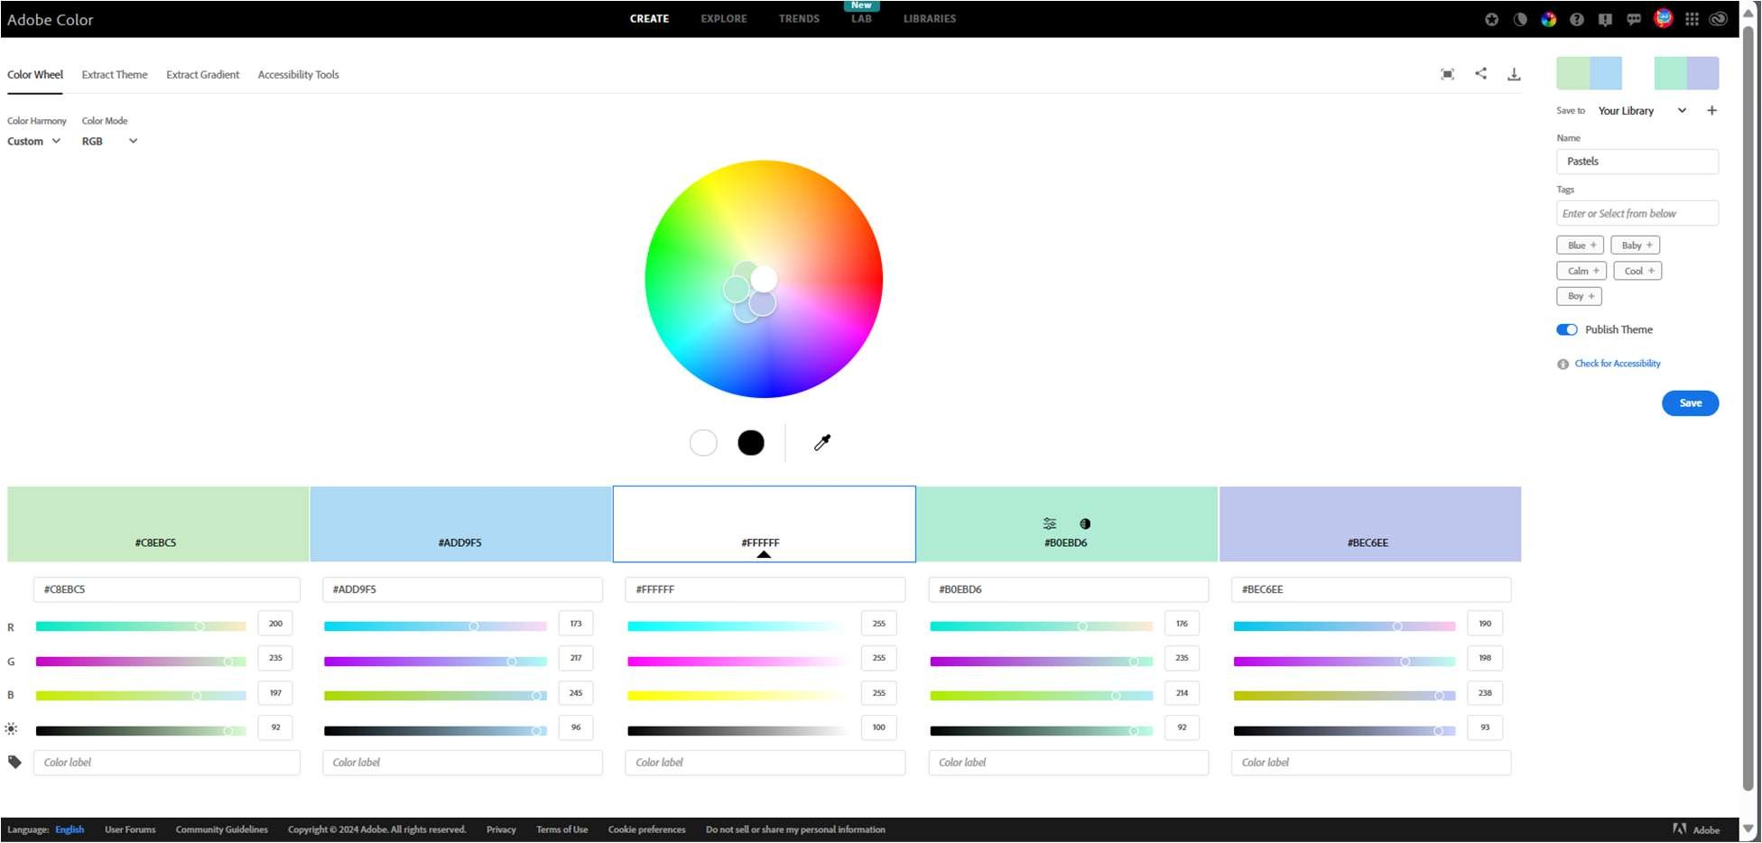

Wireframe:

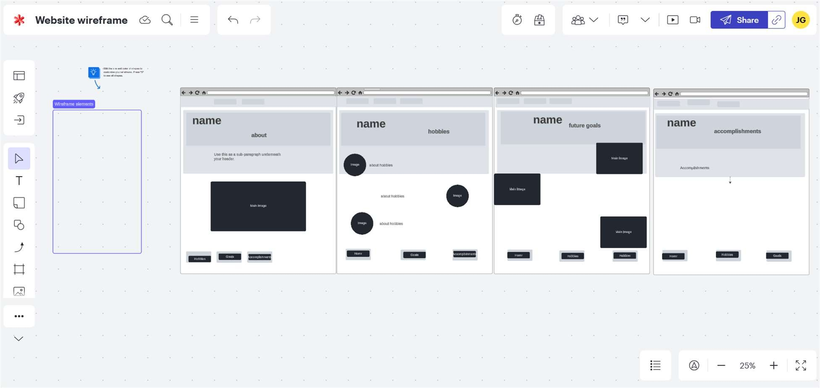

Image Hobbies:

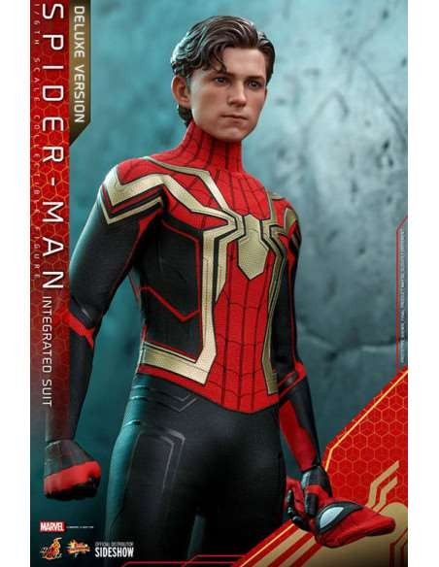

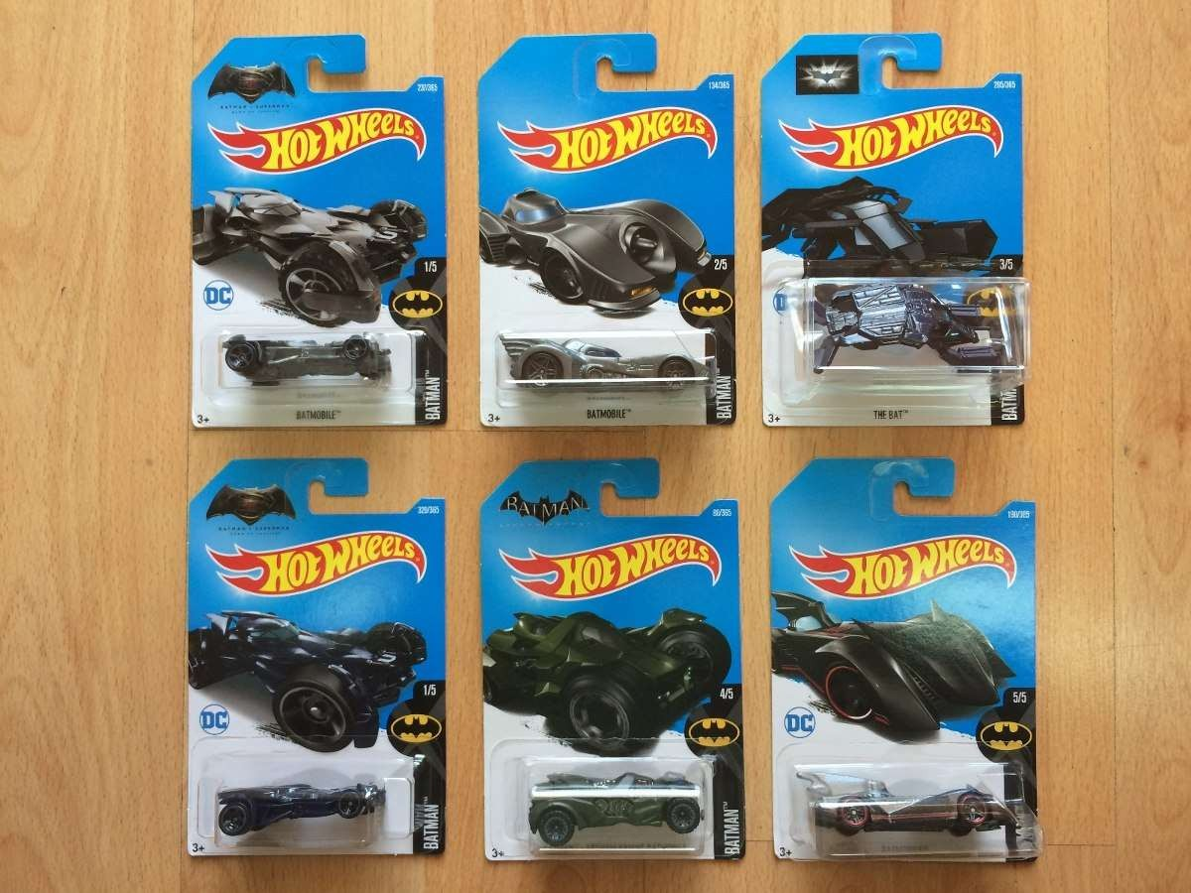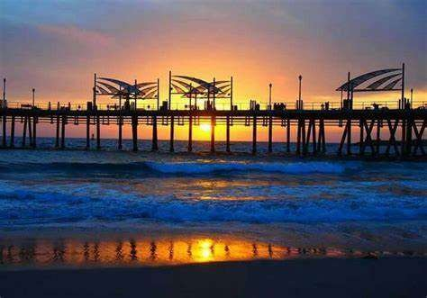

Image accomplishments:

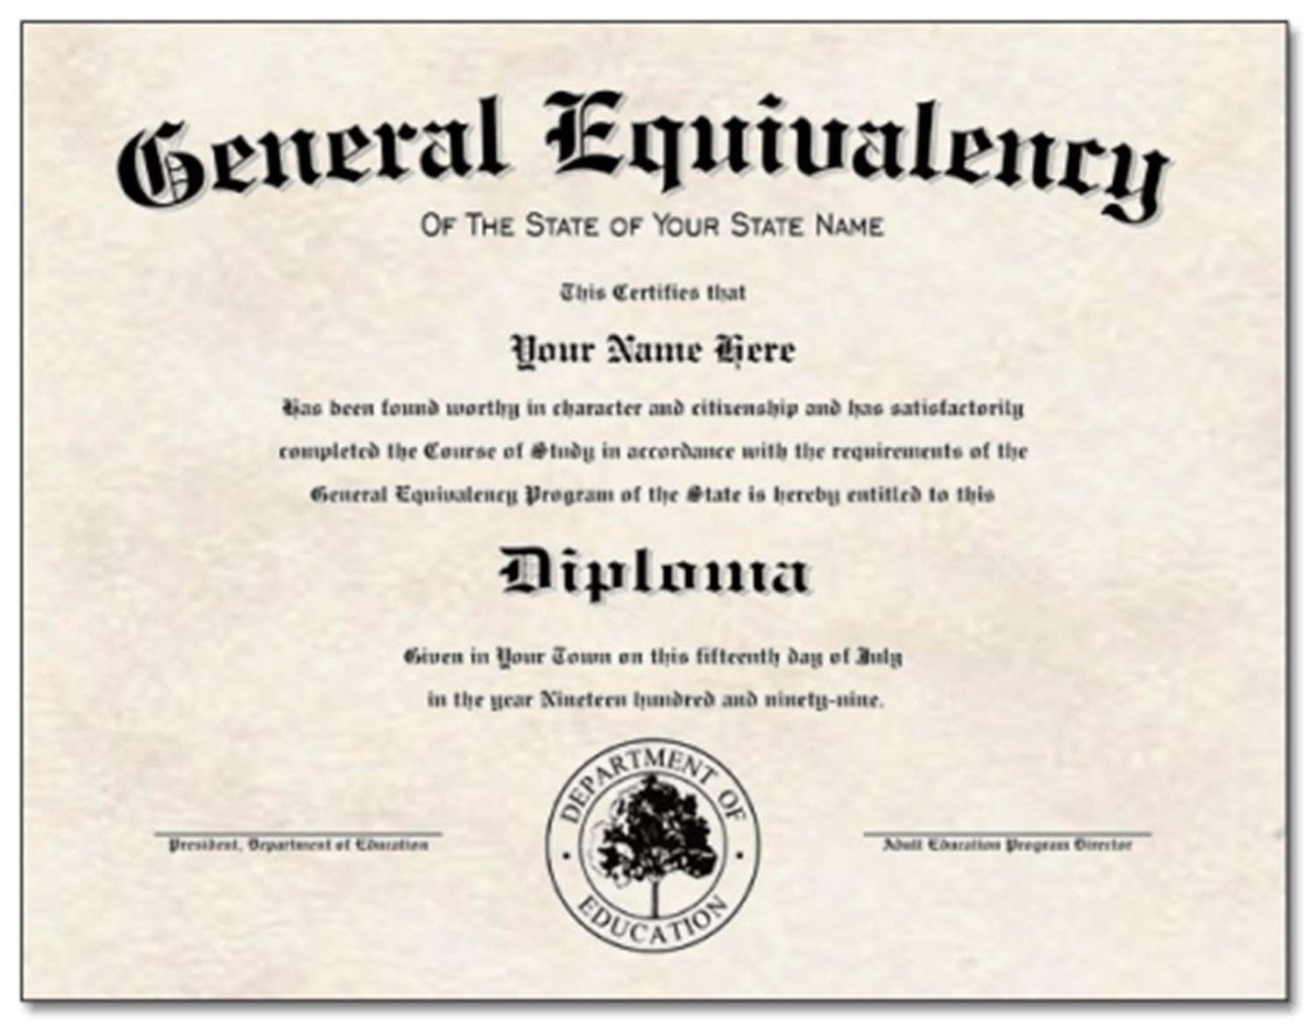

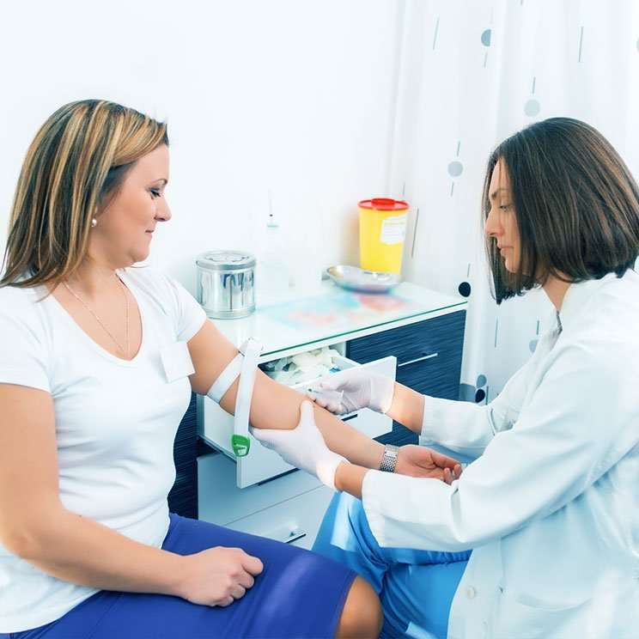

Subject Image



